Step to run:

1. Download above spring-boot application at some folder on your drive.

In my case it is under C:\Shreyas Demo\Vaadin-Project

1. Run below command to build and run server

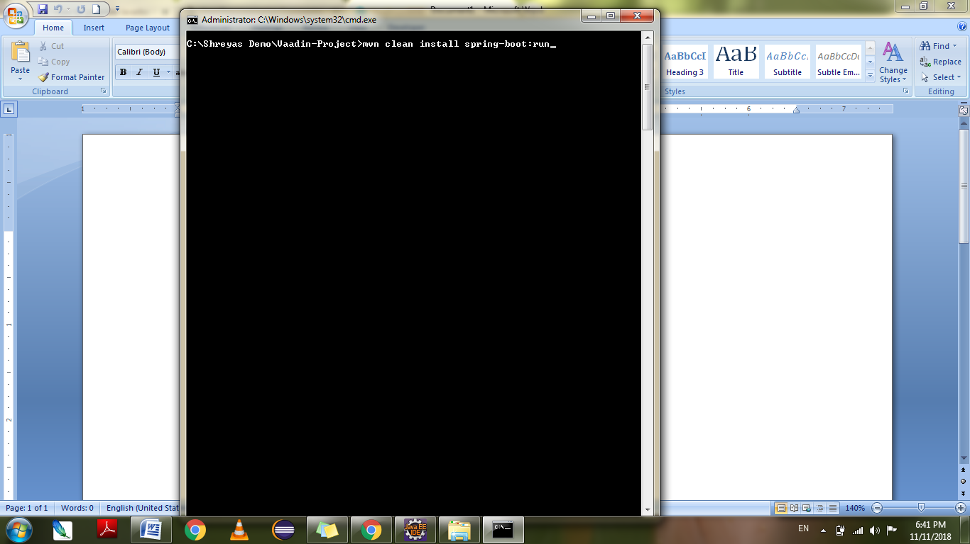

1. Go to https://localhost:8080

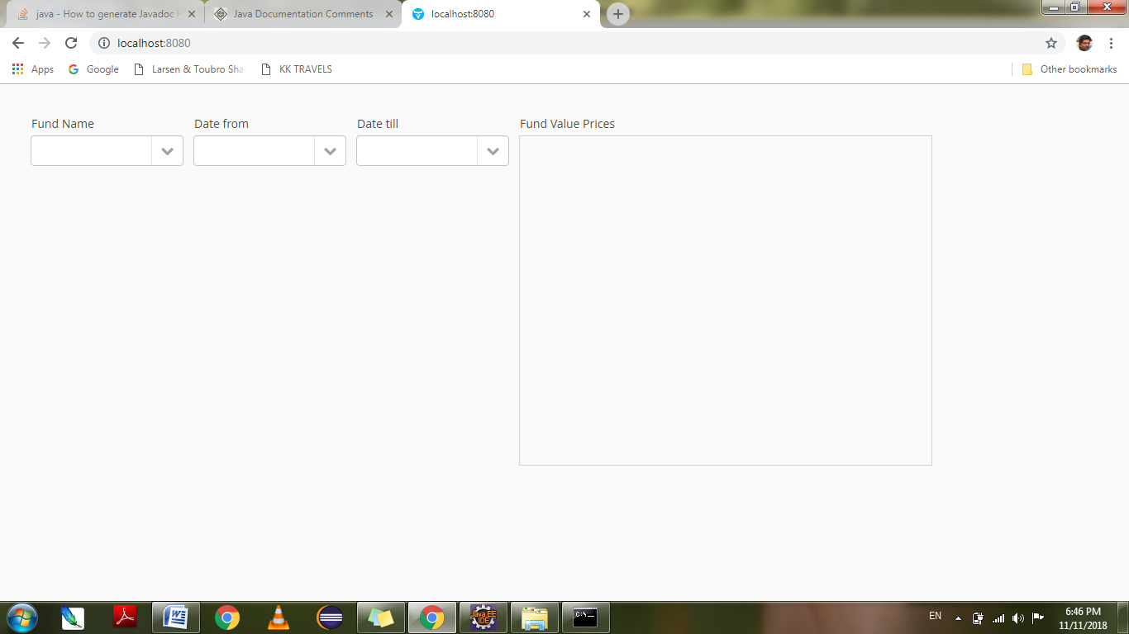

1. Select required values from Dropdown . once Date till is selected we can see values in Fund Value prices Grid view.

